Estimating takeoff ground roll without numerical methods

Define
V = airspeed
V_{LO} = liftoff airspeed
S_{g} = ground roll distance
S_{w} = reference wing area
F_{ex} = excess thrust
F_{n} = net thrust
C_{L} = lift coeffient in ground effect
C_{D} = drag coefficient in ground effect
W = aircraft weight
μ = rolling friction
g = acceleration due to gravity
A = acceleration = g*Fex/W

Assuming zero initial speed for takeoff run, ground roll distance
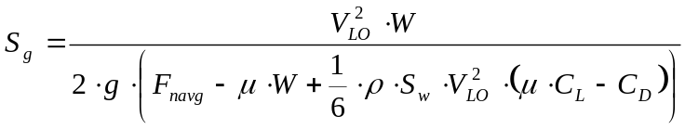
Where F_{navg} may be estimated as the average of static thrust and net thrust at liftoff airspeed. If the initial airspeed is non-zero, its value should be inserted into Equation 10.3 in place of VL/O and the answer subtracted from the zero-wind case.

Note to editior: to align this equation with text in SFTE reference handbook, please consider making the following substitutioons in the above equation
- C_{DIGE} in place of C_{D}
- C_{LIGE} in place of C_{L}
- T_{avg} in place of F_{navg}
- V_{TO} in place of V_{LO}

